Jeziel E. Torres Vazquez

INEL 4998 (Investigation Course)

Prof. Eduardo Ortiz

Week: January 18-22

This week, my main goal was to learn and understand as much as I can about OpenDss. I watch YouTube tutorials on what OpenDss was and how to use its functions to resolve a circuit. OpenDss is a simulation tool used to analyze the Impact on the Distribution System. In the simulation you must write code to create, attach and plot different lines, shapes and transformers or any necessary thing for your circuit to function correctly. I study the original code that the judges give us at the start of the competition. I did this on my own because next week the OpenDss team programs a meeting to answer any question or misunderstanding of the assigned code. Angel shared the original code with me so I can do that task.

Another task for this week was to watch the webinar that talked about OpenDss on HeatSpring. I watched 2 webinars that were from last semester about OpenDss. Specifically, they show what OpenDss was, why we would use it in the competition and how it helps to understand if the simulated circuit works. Dr. Latif is the expert on OpenDss that presents and shows this function in HeatSpring. The webinars that I watch are in the picture below mark with a green checkmark.

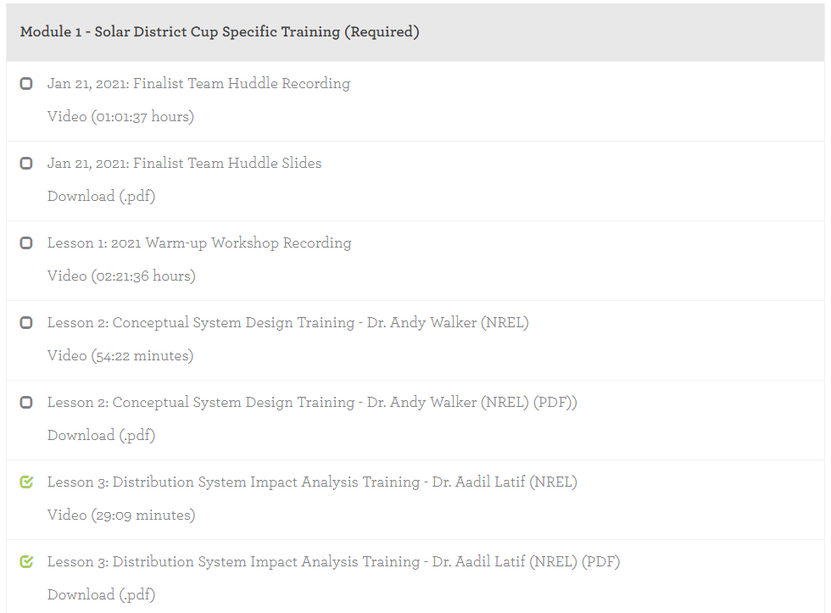

I studied this video and wrote everything important so I can use it in OpenDss. Dr. Latif talked about the importance of OpenDss for this competition. It will improve the final delivered solar system with more stability and better system overall. I learn about most of the important functions of OpenDss like plotting the circuit and see which line is where and looking at the excel files. By looking at the excel files of the resolved circuit you can see if the system has overloads or if some components can handle the voltages or currents that are passing through them. This will help a lot with choosing the right components to do the work better, more efficient, and more stable.